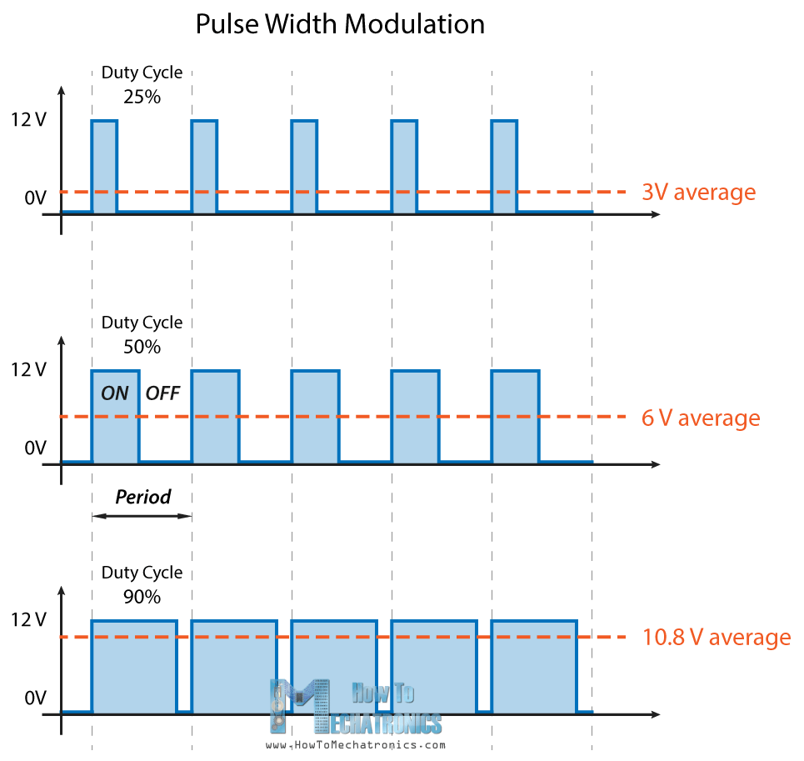

From <https://howtomechatronics.com/tutorials/arduino/arduino-dc-motor-control-tutorial-l298n-pwm-h-bridge/>

Simple PWM generator in MSP:

#include <msp430g2553.h>

**int** main(void) {

WDTCTL = WDTPW + WDTHOLD; //Disable the Watchdog time

P1DIR |= BIT2; //Set pin 1.2 to the output direction.

P1SEL |= BIT2; //Select pin 1.2 as our PWM output.

TA0CCR0 = 1000; //Set the period in the Timer A0 Capture/Compare 0 register to 1000 us.

TA0CCTL1 = OUTMOD_7;

TA0CCR1 = 500; //The period in microseconds that the power is ON. It's half the time, which translates to a 50% duty cycle.

TA0CTL = TASSEL_2 + MC_1; //TASSEL_2 selects SMCLK as the clock source, and MC_1 tells it to count up to the value in TA0CCR0.

__bis_SR_register(LPM0_bits); //Switch to low power mode 0.

}

Source: <https://www.kompulsa.com/example-code-msp430-pwm/>

H-Bridge : <https://www.kompulsa.com/example-code-msp430-pwm/>

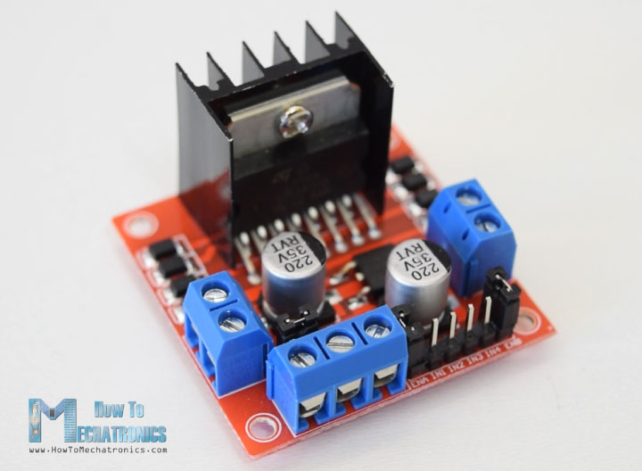

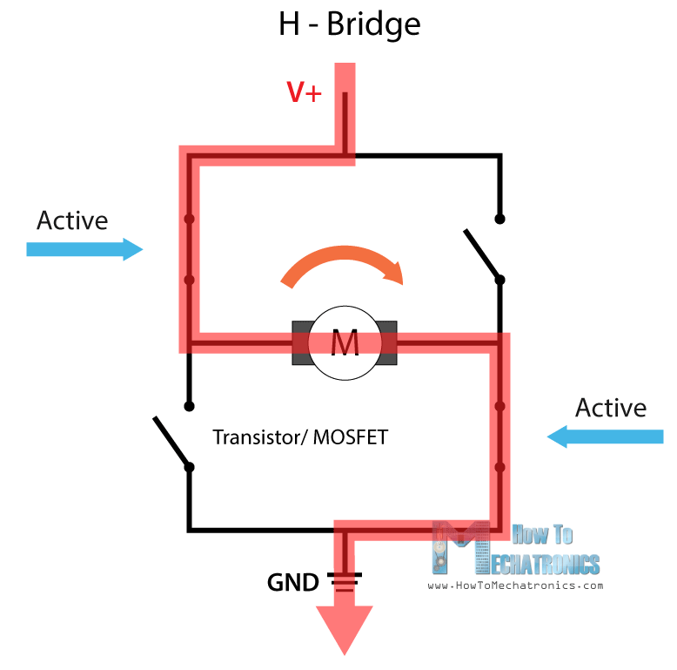

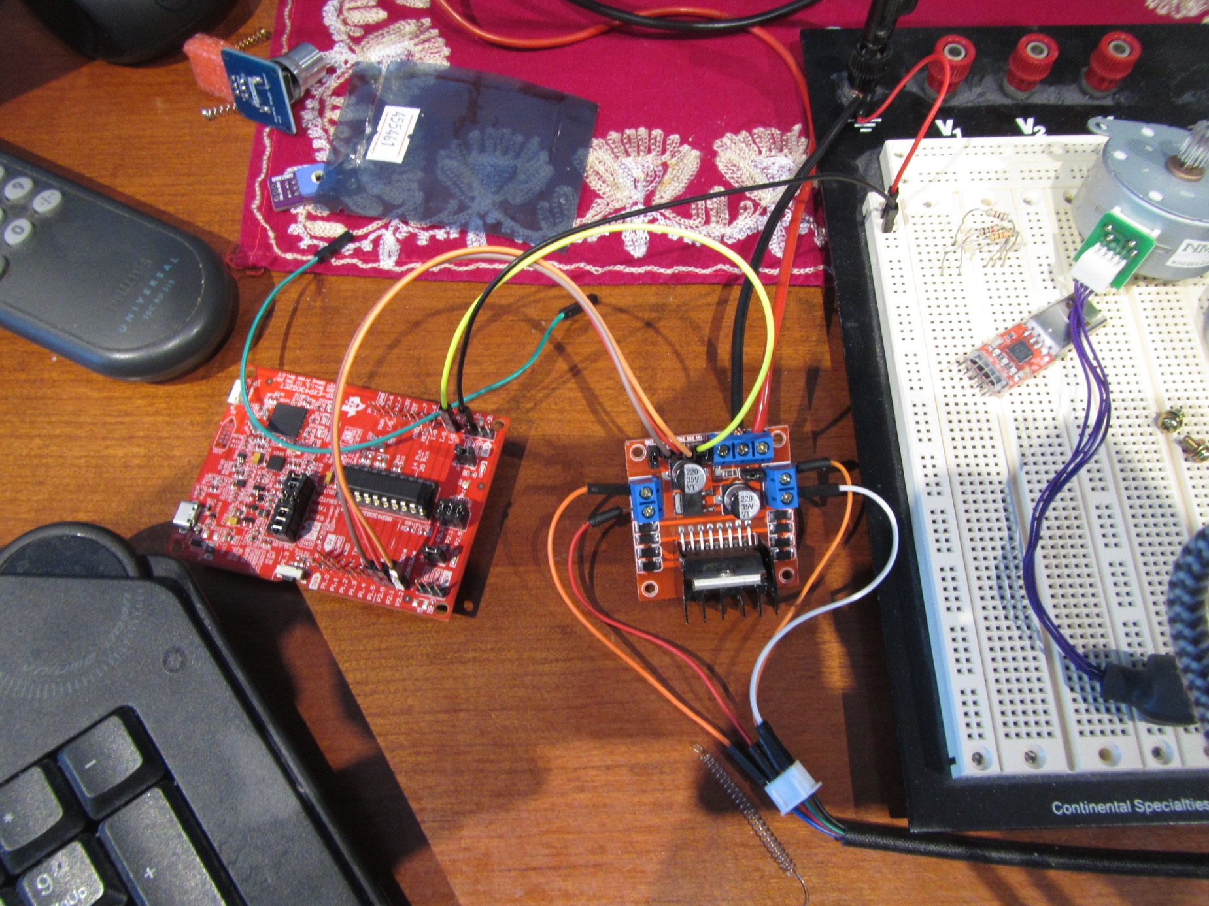Stepper motor control